**QA Test Engineer**

**Take Home Test**

**Scenario**: You are given the task to test out a new area of the website that gives the user the ability to reschedule a previously scheduled meeting with a Financial Advisor. You are given both an image of the design and acceptance criteria / requirements. Please review them below:

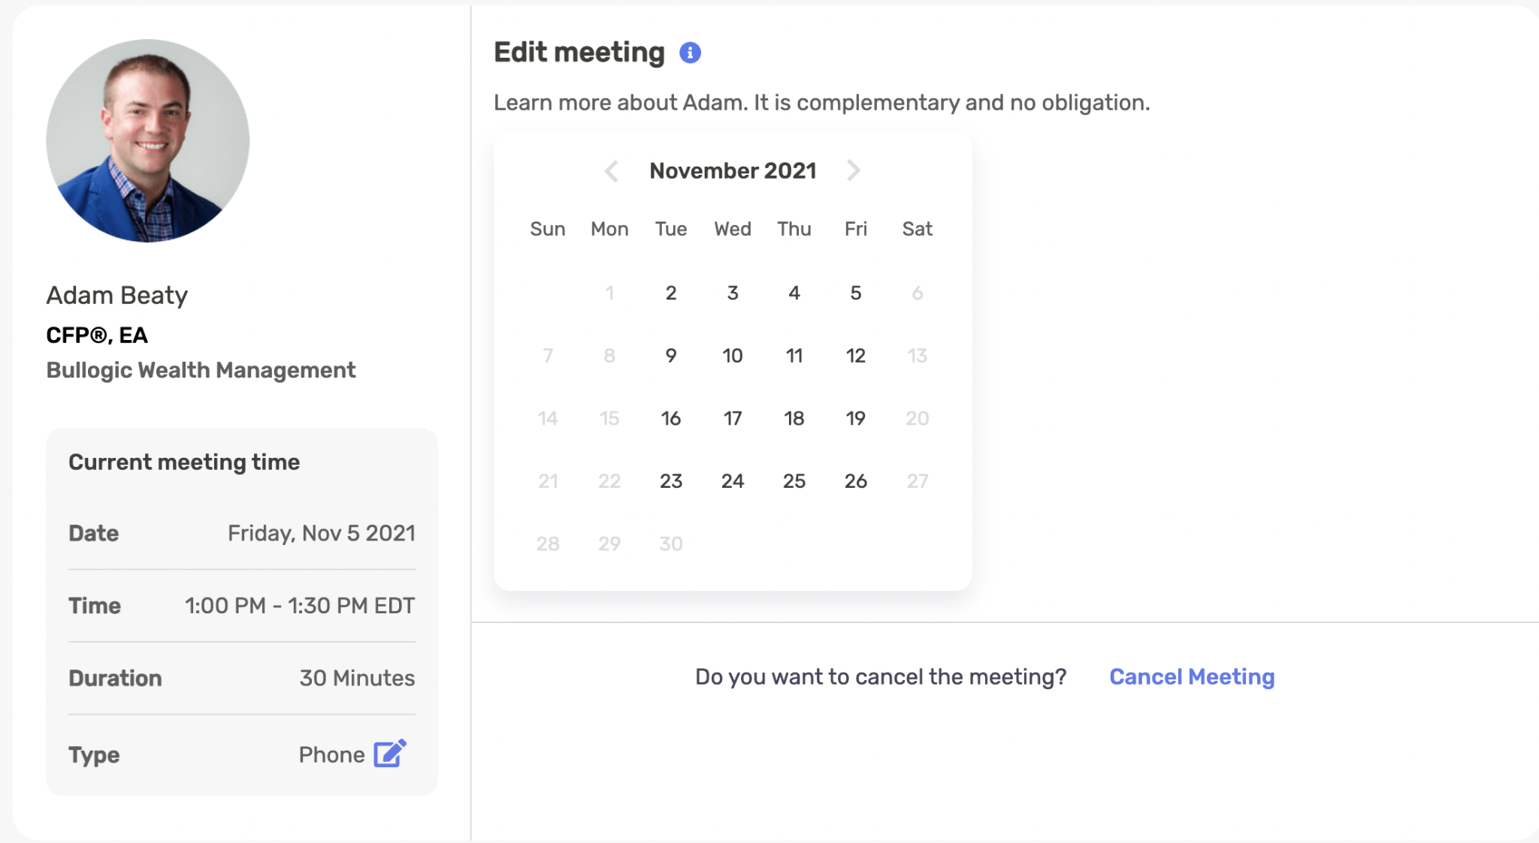

**Acceptance Criteria / Requirements:**

Users should see a reschedule meeting module in which they are presented with the following information:

- Information about their current meeting time

- Information about the advisor they are scheduled with

- A calendar interface that allows user to see advisor meeting availability

- An interface that allows the user to schedule a new meeting date/time

**Task 1** : Write a list of questions or uncertainties you may have that you would ask a stakeholder (designer, front or back end dev, product, content, etc) concerning the image or acceptance criteria/requirements.

* What is (are) the database(s) used for retrieve the information deployed in the reschedule-card? It is important to check the succesfull modification of the information on the database once the user finish the reschedule flow.
* It is important to execute a load test for the system when a massive number of users are trying to modify the previous meetings scheduled?
* Is there any mock in Figma (or similar) to check the behavior of the UX flows defined by the Designer or Design area?
* What is the main User Story created in Jira (or similar) for tracking this feature? Someone could provide it me, please? I will create a card for test this feature and I need to upload the main information related with the expected time for finish this process (and the spent time at the final of the day, of course).
* Is it possible to display the time in the current time zone oif the user? I noted that the period of time is set in EDT zone. It cpould be annoying for the user if it is in far place from this time zone. This is a suggestion that I find relavant for our product if we want to have a frictionless experience for our clients.
* When the cursor is hold over the blue information icon next to “Edit Meeting” text, a pop-up message appears over the calendar box. This could be annoying for some users, but it is not a big mistake (I mean, this could be fixed in the next release). However, I want to check the behavior in a small device like a smartphone. Is any design defined for this specific dynamic?
* Although is not a technical mistake, when a user chooses a different month that the original one display in the card, I consider that the calendar box would not change its size according to the number of days. It will be better if the size is fixed to the maximum size available. I will write this commentary to the Jira card. Still I want to consider you opinion about this point. What do you think?
* Due to bussiness model, I suppose that this webpage will be used on smartphones, tablets and notebooks. In that case, it is important to check the rescheduled-card design for differents resoutions. Could anyone in the team provide the original design created?
* Taking account the above question, it will be requred to review the performance and the behavior of the reschedule module in differents OS for smartphones (mainly, Android and MacOS). Someone in the team could execute a smoke test in an iPhone after the release is completed in PRD environment? Of course, I can check in an Android device.

**Task 2:** Imagine that you find a defect while testing the reschedule experience of Task 1. Write a sample defect report below. If any information is missing, you can use fake data:

*[Assuming that the enterprise use a platform like Jira or similar, the next information will be attached to the card or story defined for this feature]*

**Env:** STG

**Version:** release__ZF12.7.0

**Type:** UX

**Assigned to:** (Name of the developer responsible for this task)

**Description:** When the field “type” of a meeting is the unique value modified by an user, the webpage is freezing after the user clicks on the Confirm button.

**Expected Behavior:** The webpage should be closed automatically when the user modify the type value.

**Current Behavior:** The webpage is not redirected to the previous page visited by the user. It frezees and there is no response when the user clicks outside the pop-up confirmation box.

**Steps to reproduce:**

* 1. Visit main url ([www.successful-enterprise.com](http://www.successful-enterprise.com/))
  2. Log in with mock credentials for use testing user.
  3. Go to hamburger menu.
  4. Click on Meeting.
  5. Choose one of the meeting displayed in the interface.
  6. Search and click on the “Modify Meeting” blue button.
  7. In the new webpage displayed (reschedule meeting module), identify the field “Type” related to the meeting information.
  8. Click on the icon next to the value of the “Type” field (the one with a pencil writing on a paper)
  9. Choose a type of meeting different to the original one.
  10. Click on “Confirm” button and check the behavior of the flow.

**Task 3: Automation assignment**

You can find the form by going to https://portal-test.zoefin.com/reschedule/66965aa0-9c17-11ed-b52a-53af9ee871d5

Please write an automation script to verify one use case you think is worth for automation.

Let us know about any edge cases you can think of. Feel free to write the script in Selenium, Puppeteer, Cypress, Javascript in the developer console, or any other tool you’re comfortable with.

You may submit your work by providing a link to your GitHub repo. Make sure the code runs. We will review it live during our interview.

**Task 3: API Testing**

Using this API <https://jsonplaceholder.typicode.com/> execute the following Test Cases:

*Feel free to use any tool that you want to run the API.*

1. **Test Case: API Request for Users**
   * Send a GET request to the /users/8 endpoint.
   * Verify that the response contains fields “phone” & “website”
   * Paste the payload and status code received here.
2. **Test Case: Create a New Post**
   * Send a POST request to the /posts endpoint with valid data.
   * In one of the fields requested in the body add the date (today).
   * Paste the payload and status code received here.
3. **Test Case: Update a Post**
   * Send a PUT request to the /posts/*10* endpoint with valid data.
   * Verify that the response confirms the successful update of the comment.
   * In one of the fields requested in the body add the date (today).
   * Paste the payload and status code received here.
4. **Test Case: Update a User**
   * Send a PUT or PATCH request to the /user/*8* endpoint with valid data.
   * Change only the username field with this data: “zoe-todaydate”.
   * Paste the payload and status code received here.